

**Name -Atrayee Pathak**

**Sap id – 500105632**

**Roll no – R2142220243**

**Scenario:**

**Imagine you are a developer contributing to a main repository. Your task is to update files in the**

**main repository while following a structured workflow using branches, pull requests, and**

**merges.**

Task 1: Basic Fork and Pull Request

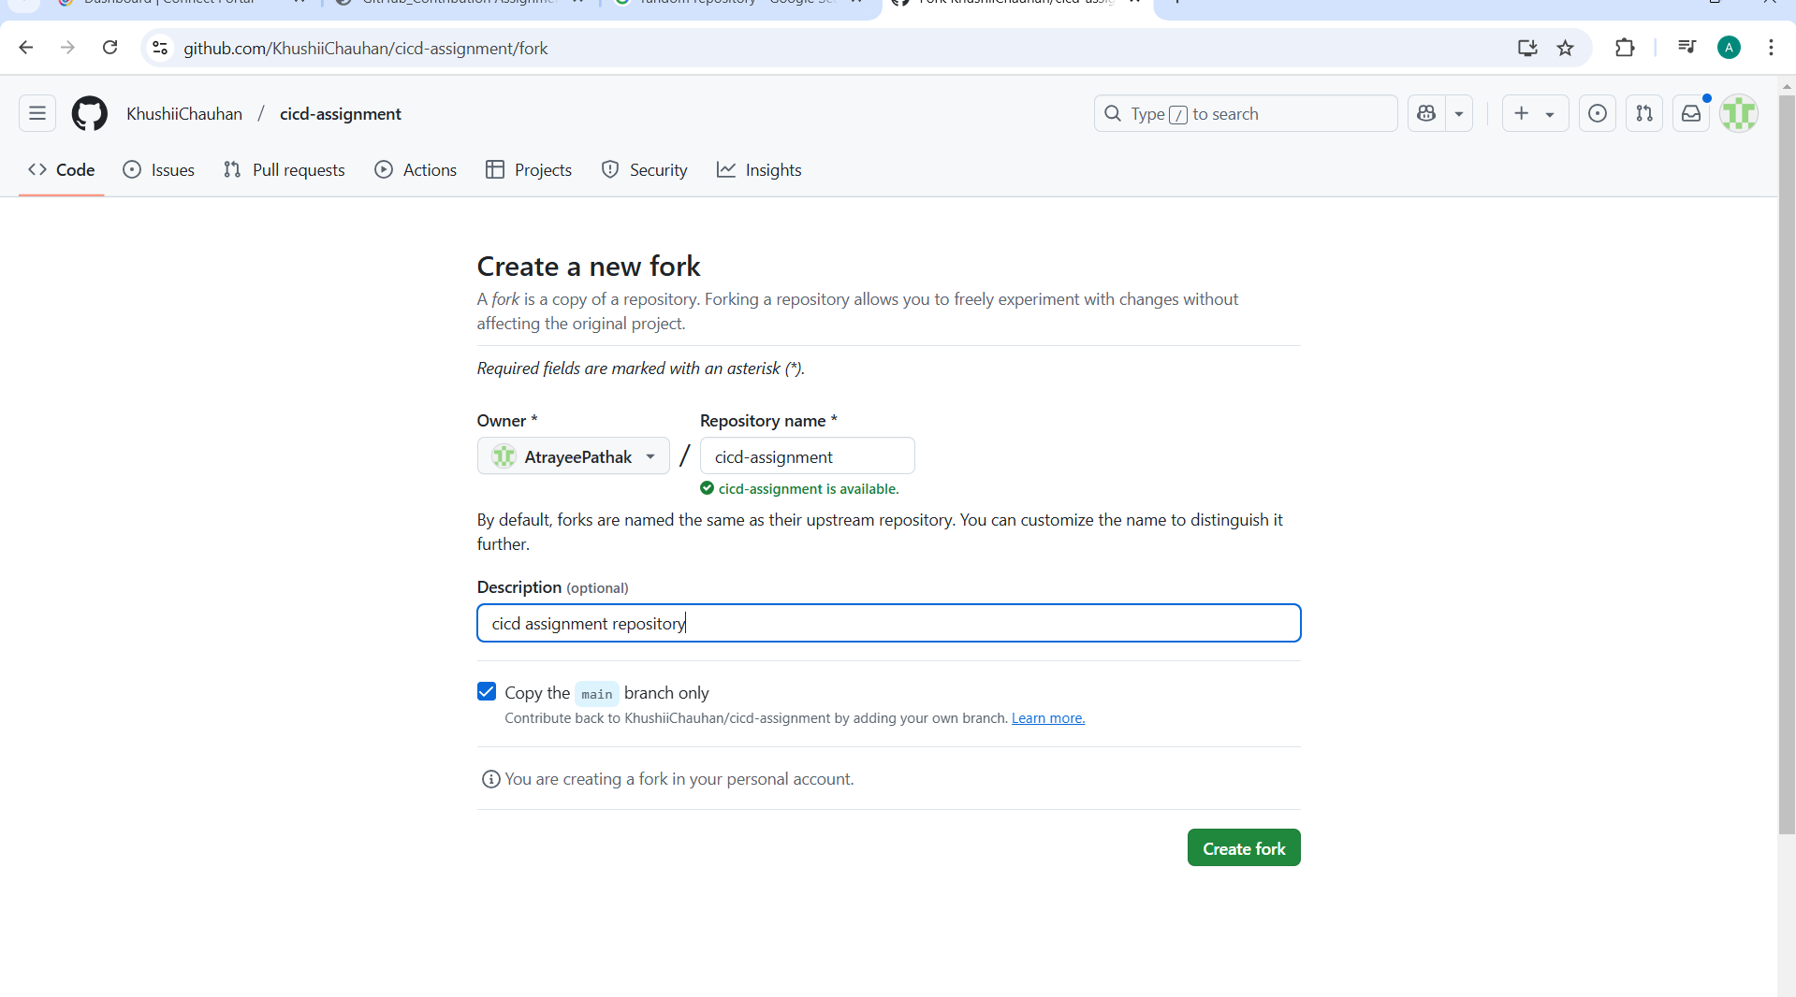

Create a new branch named branch1

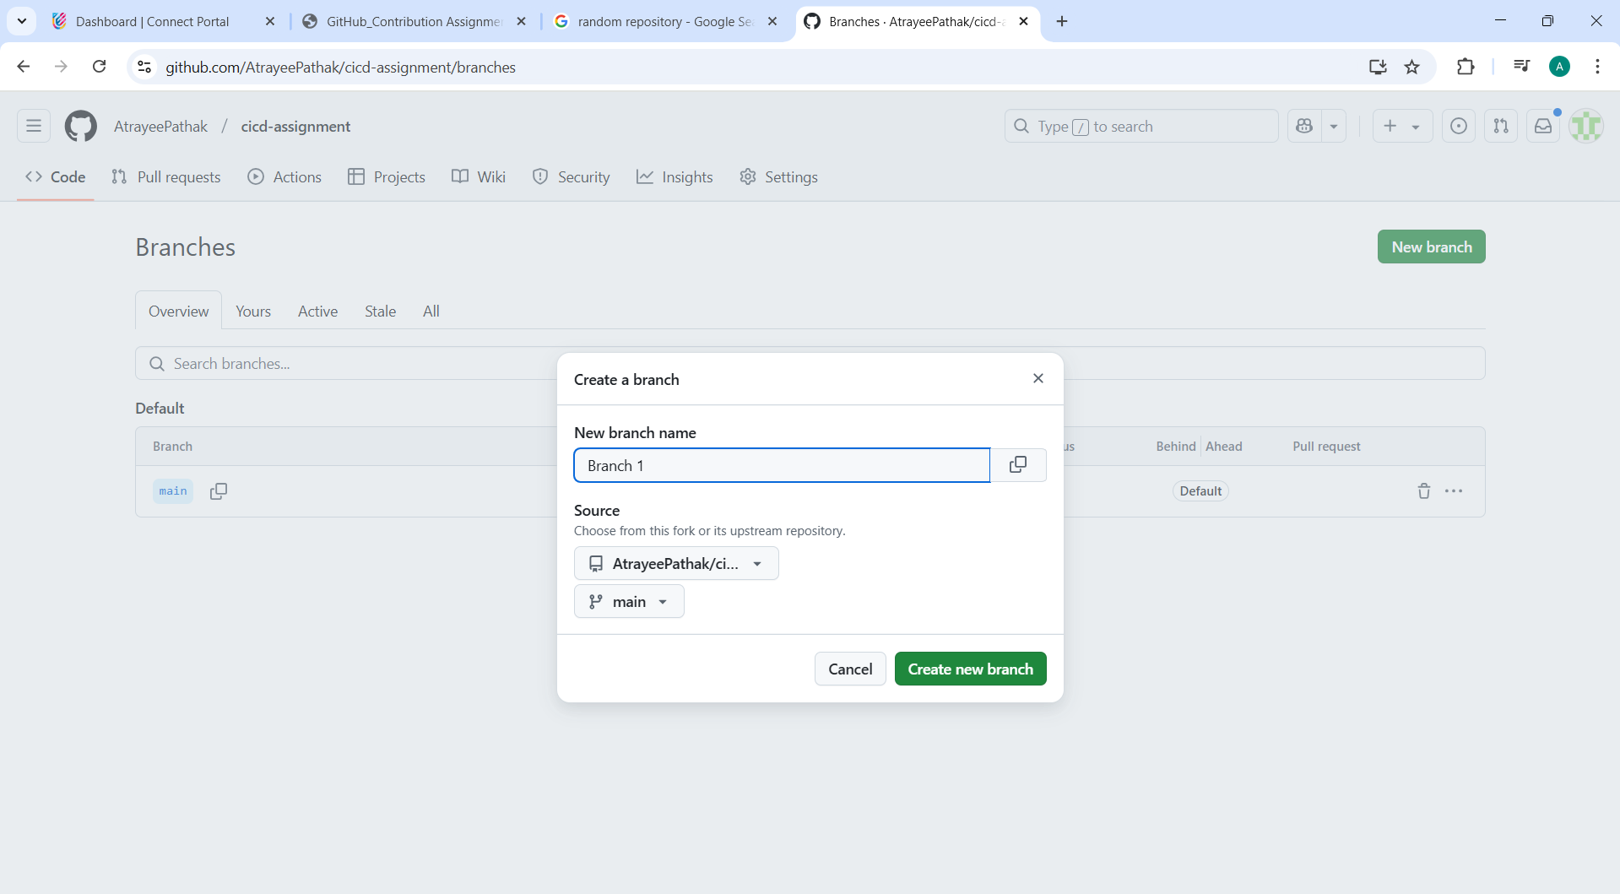

**Modify the README.md file**

* Open README.md and add:

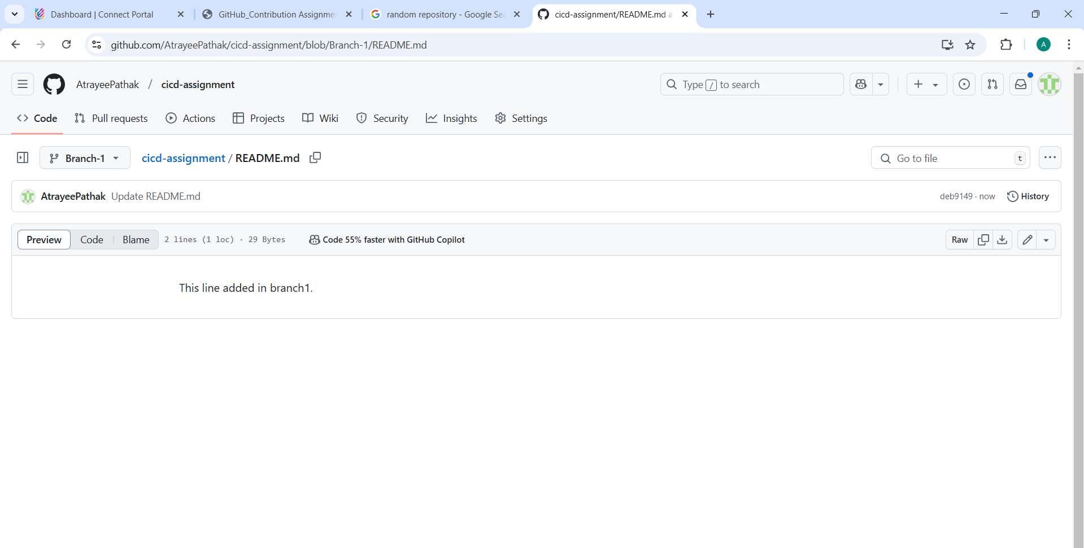

**Create a pull request (PR) on GitHub**

* Go to your repository on GitHub.
* Click **Compare & pull request**.

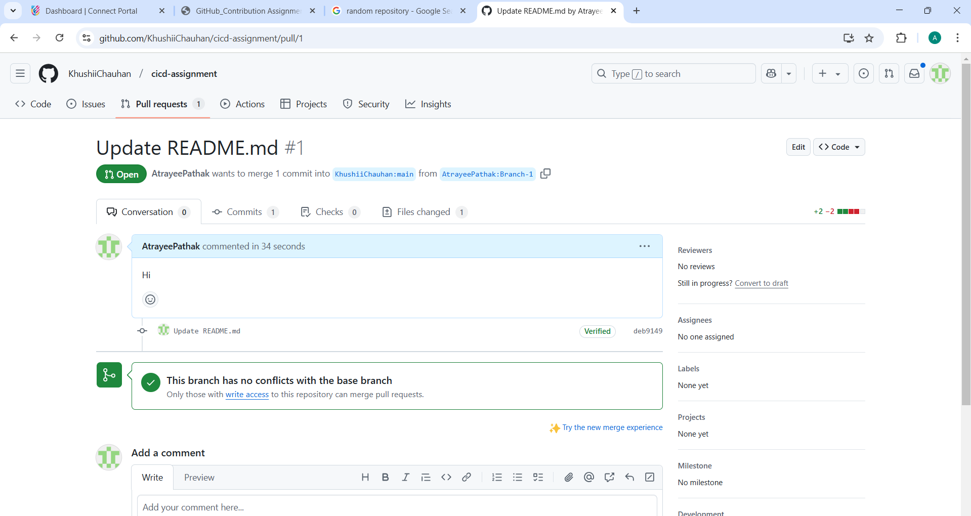

**Merge the pull request into the main branch**

* Click **Merge pull request**, then **Confirm merge**.

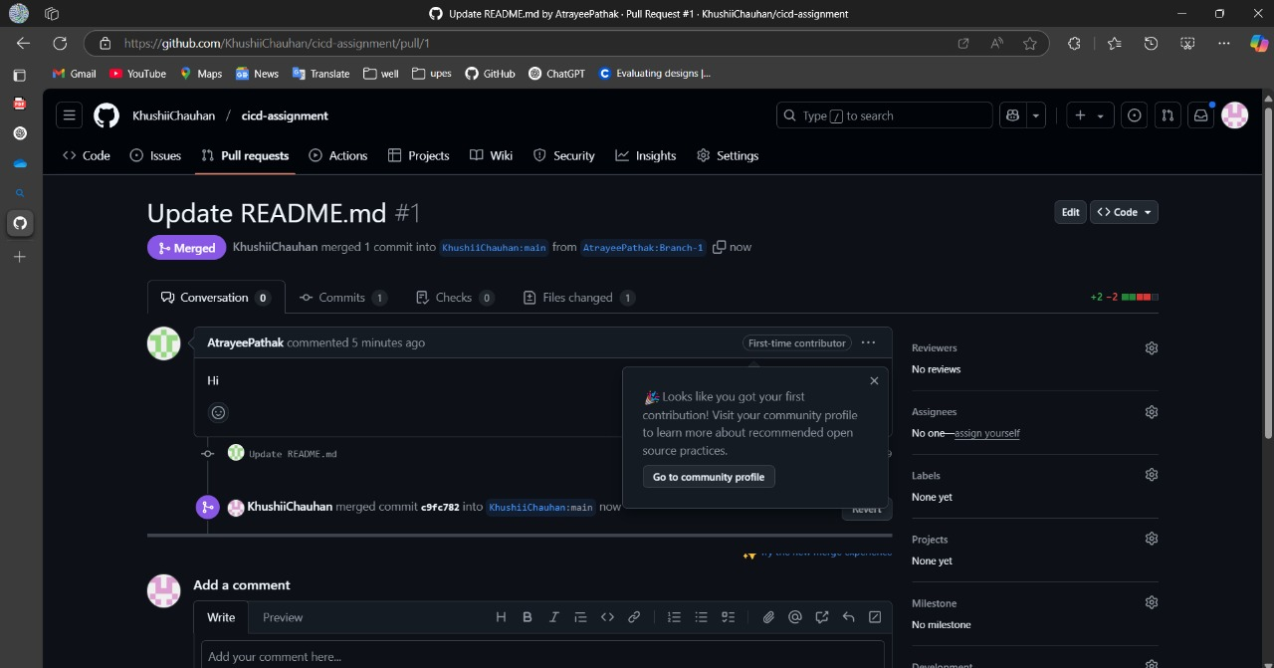

**Task 2: Adding a New File While Updating README**

1. **Follow steps 1–3 from Task 1.**
2. **Modify the README.md file as before.**
3. **Switch to the main branch and add a new file**

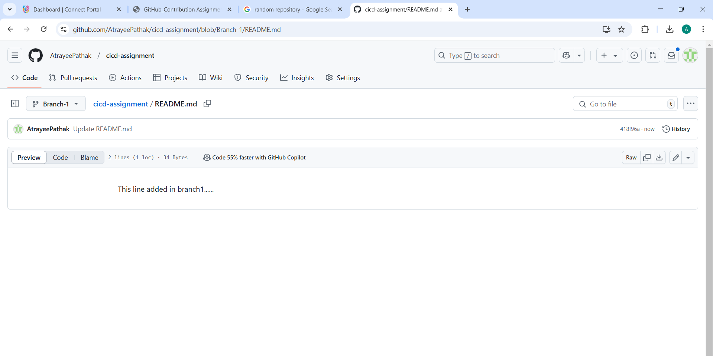

**Switch back to branch1 and push changes**

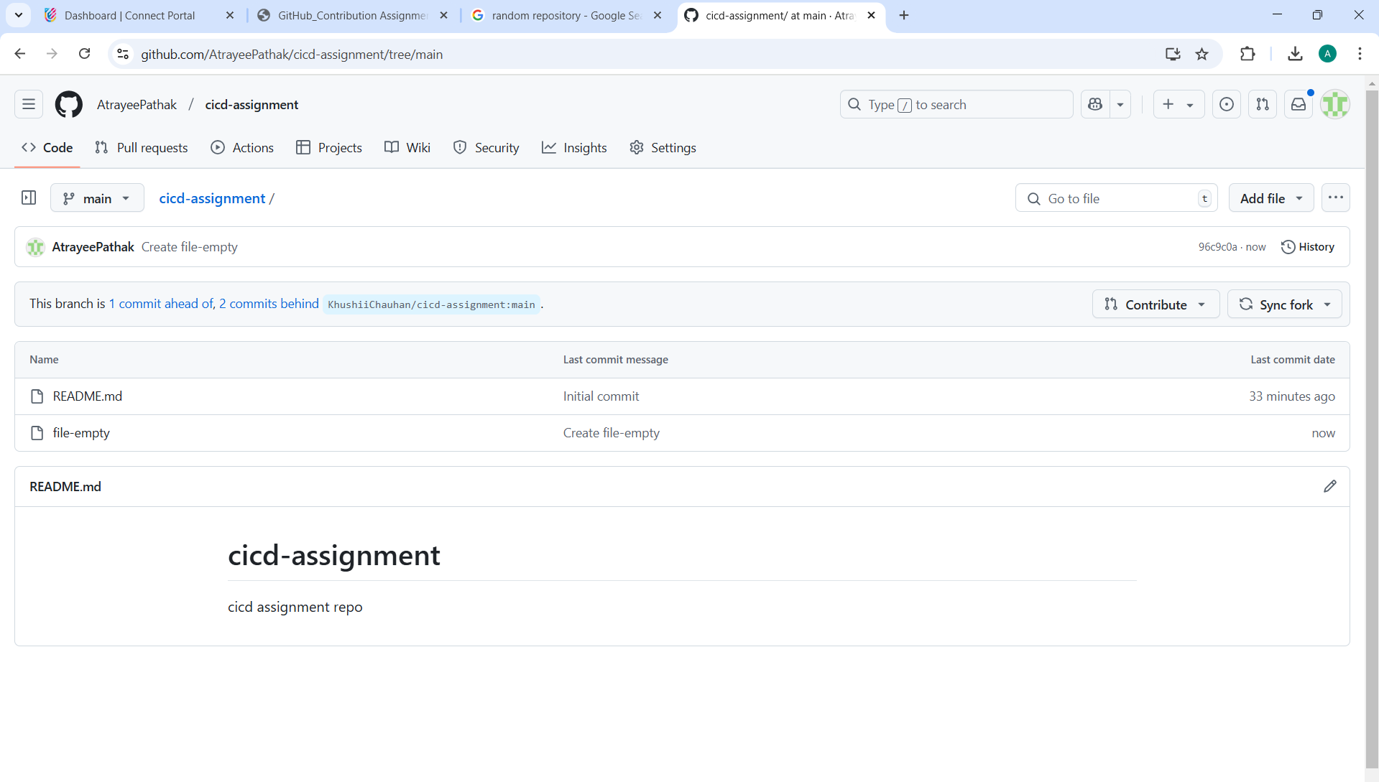

**Create and merge a pull request for branch1.**

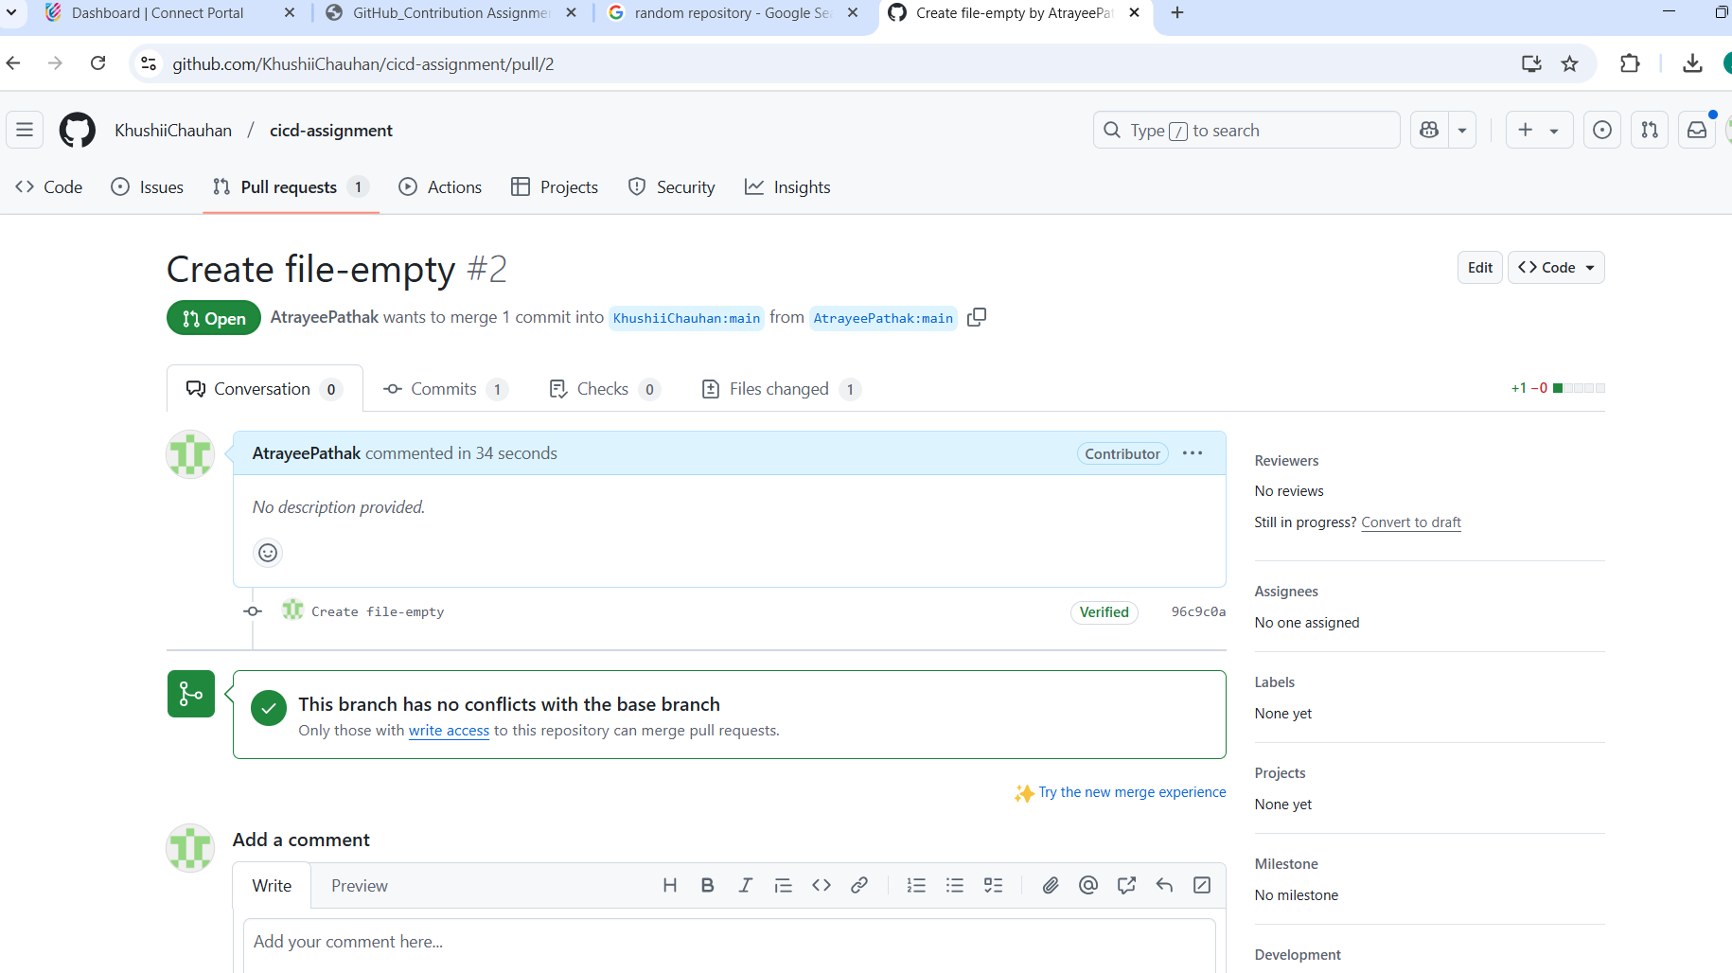

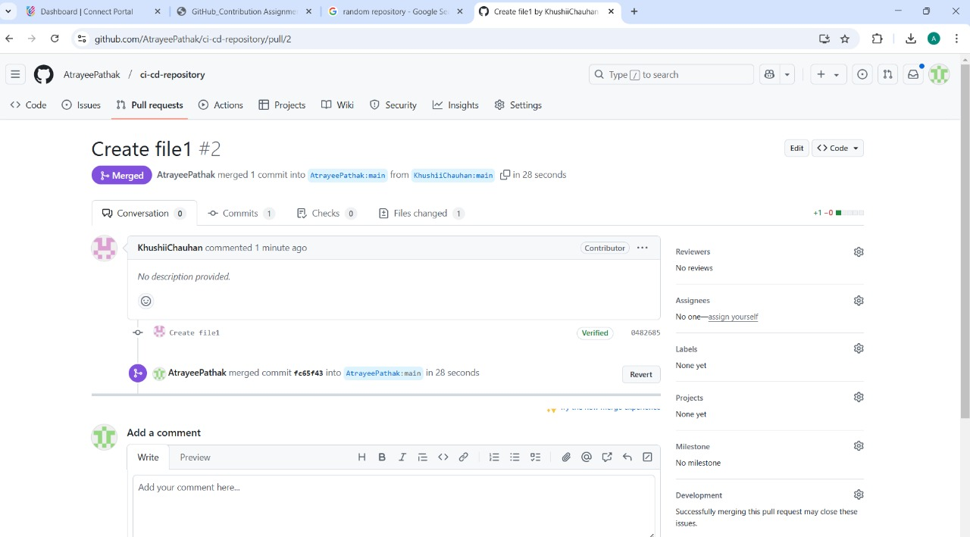

**Task 3: Handling Concurrent Modifications**

1. **Follow steps 1–3 from Task 1.**
2. **Switch to the main branch and modify README.md**

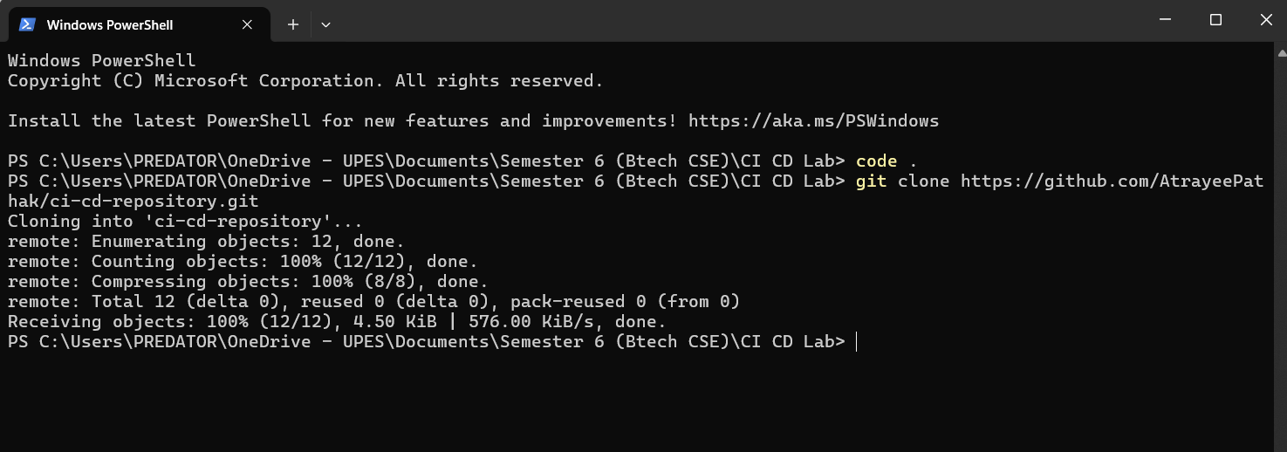

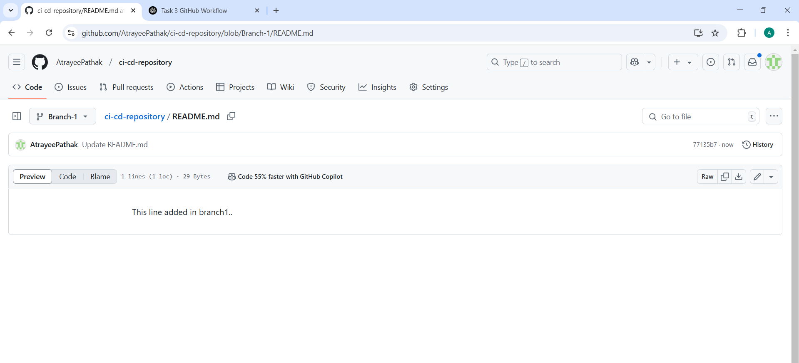

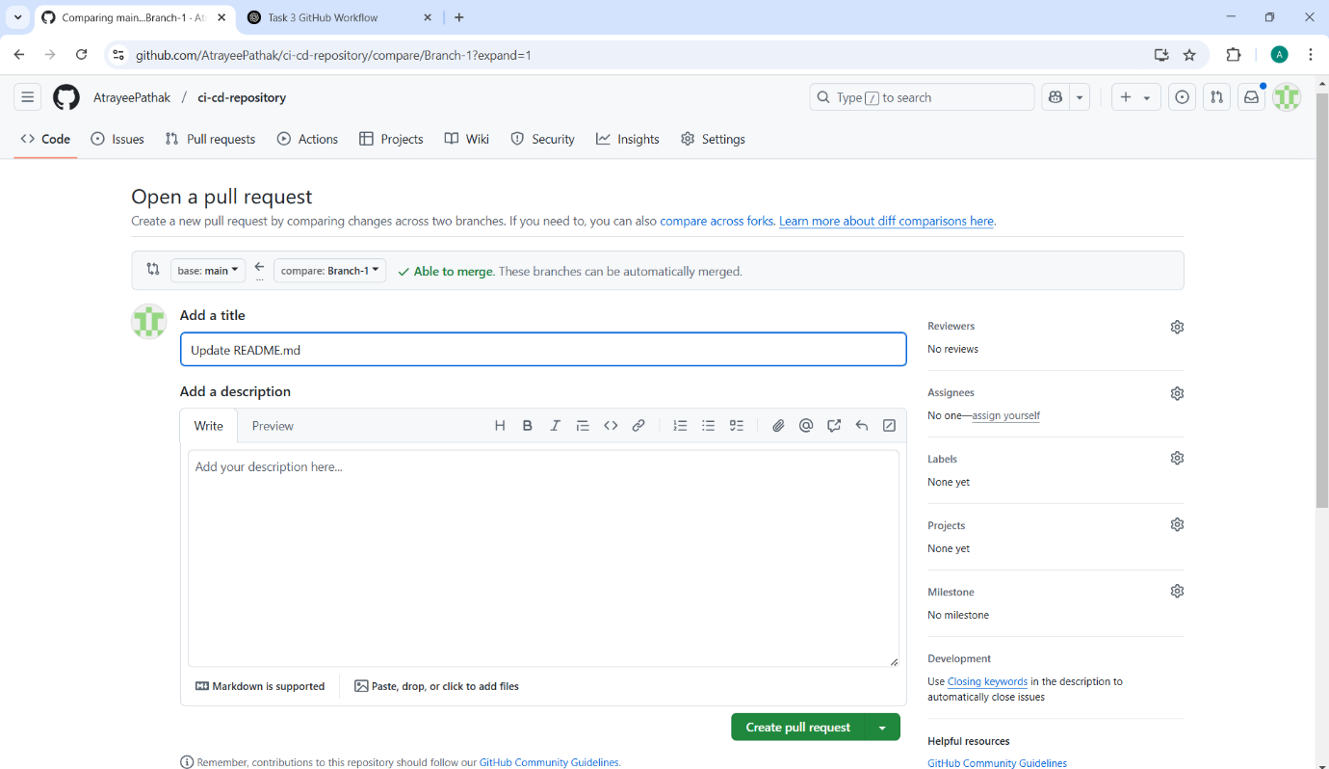

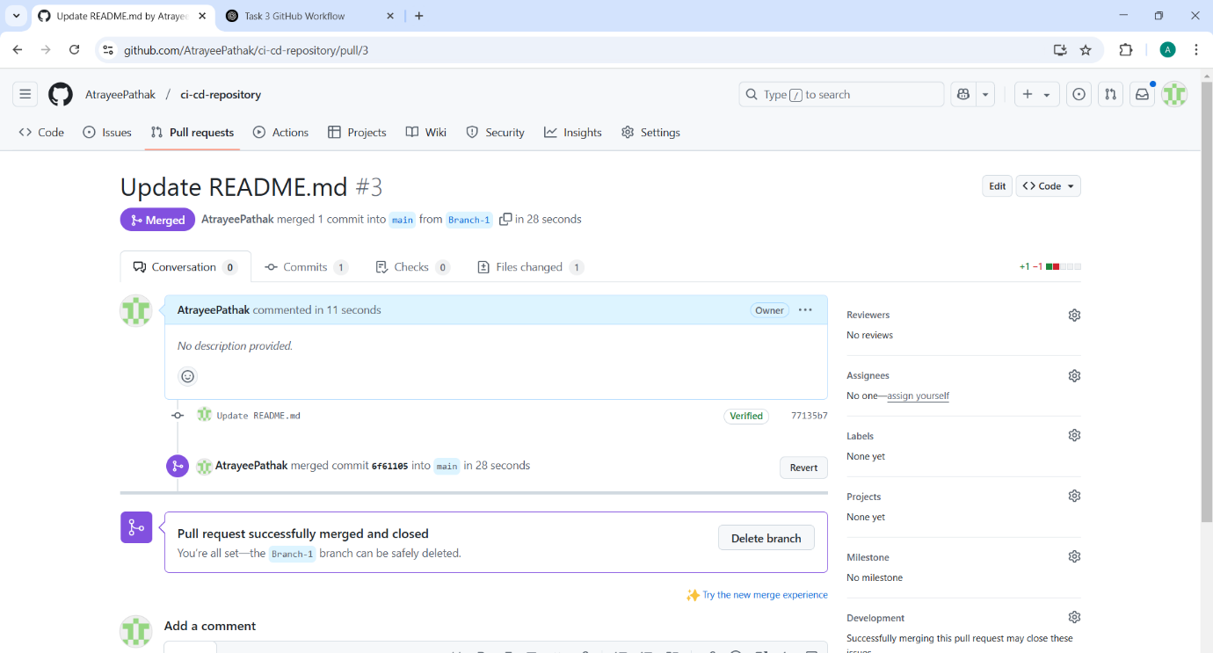

**Task 4**

**1: Basic Fork and Pull Request (Local)**

**Create a New Branch and Modify README**

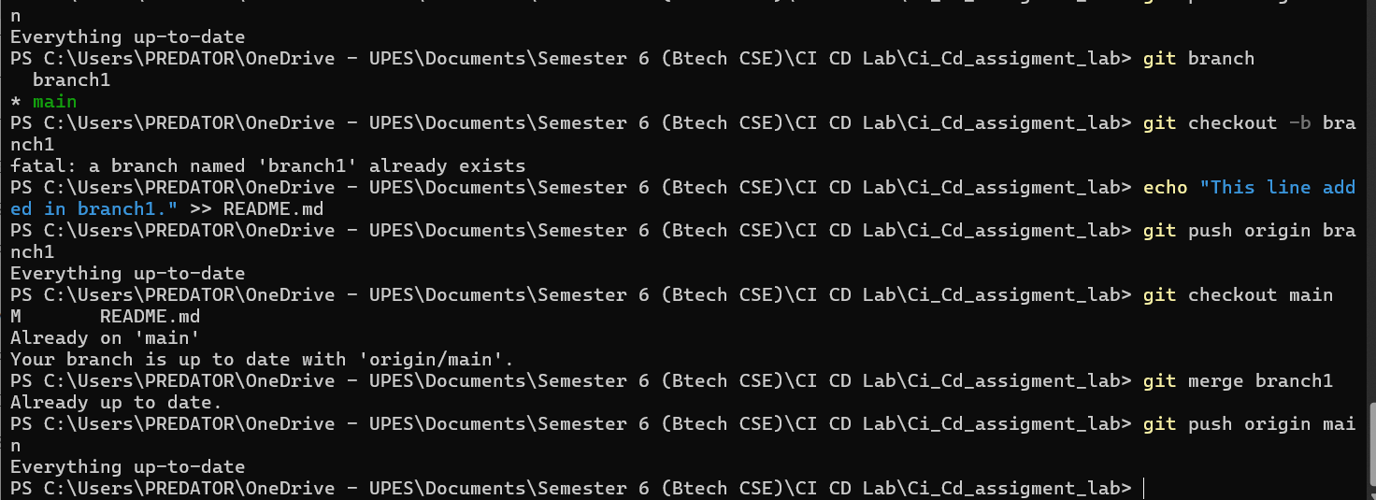

**2: Adding a New File While Updating README (Local)**

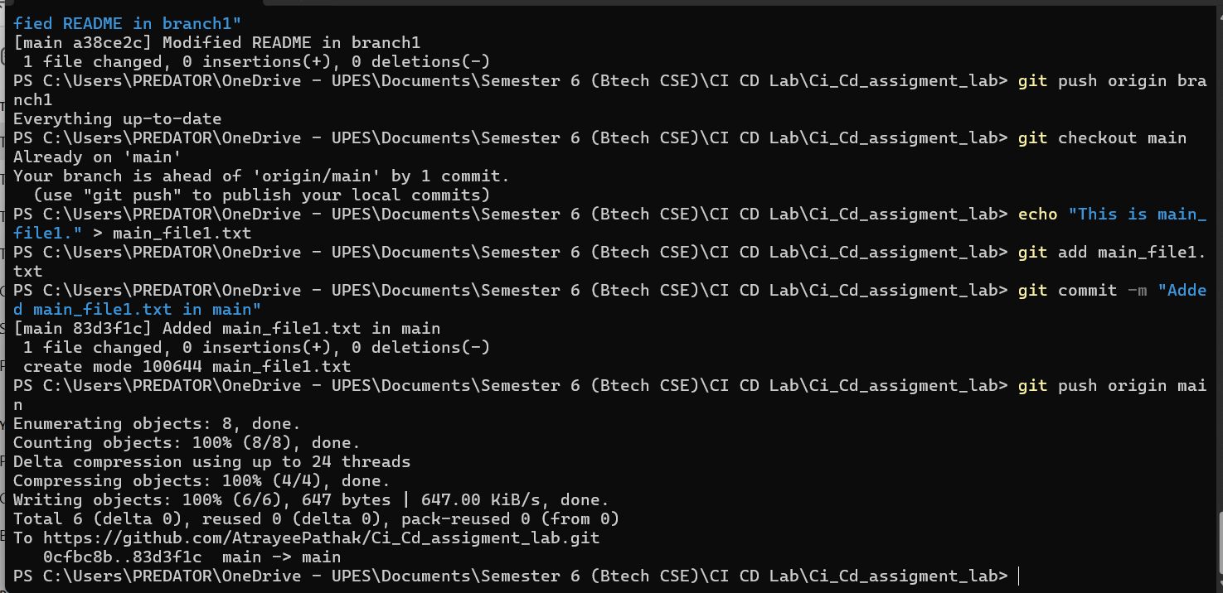

**Merge branch1 into main Locally**

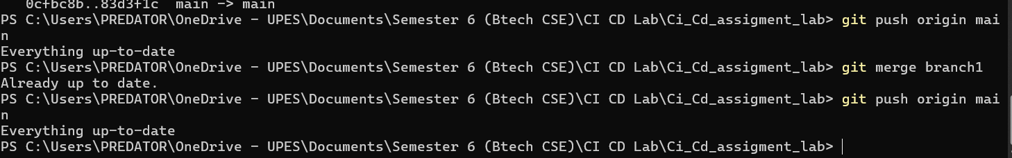

**3: Handling Concurrent Modifications (Local)**

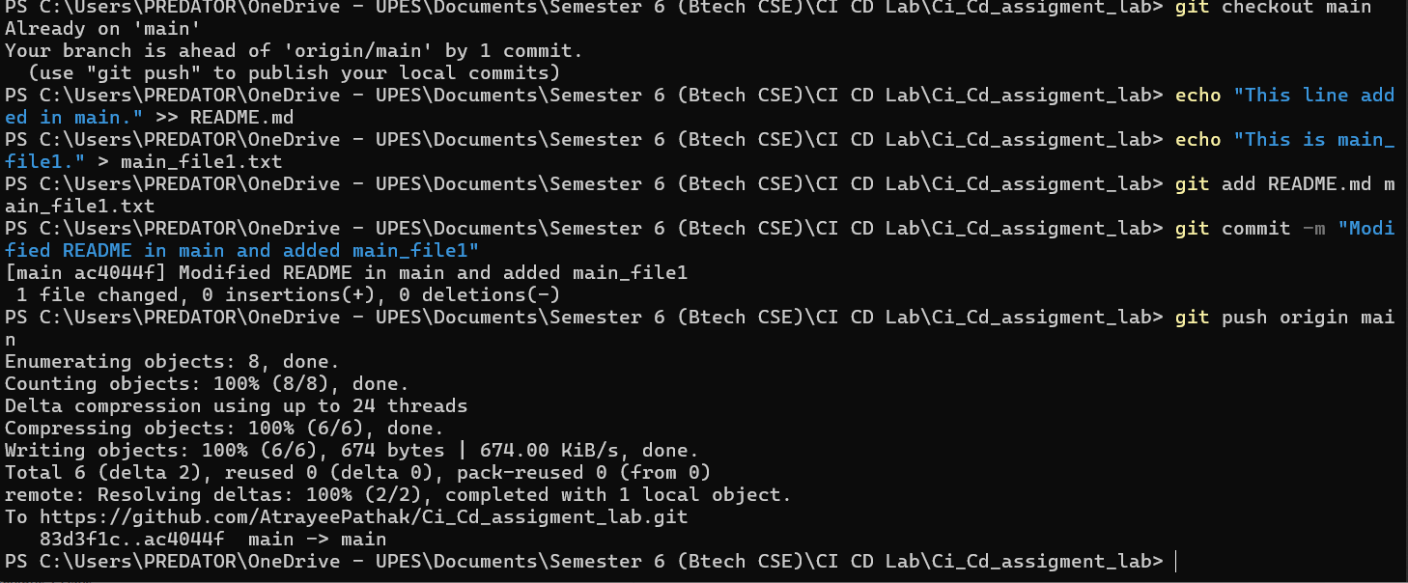

**Merge branch1 into main Locally and Resolve Conflicts**

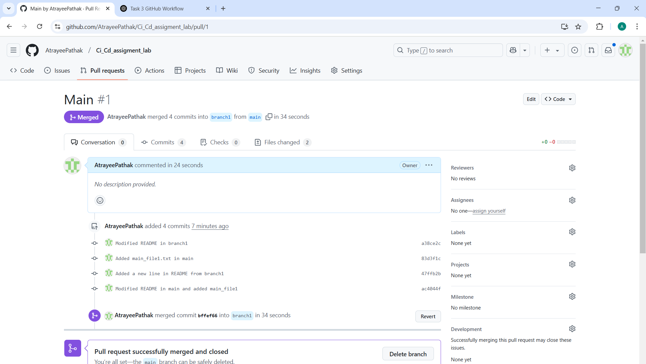



**Task 5**

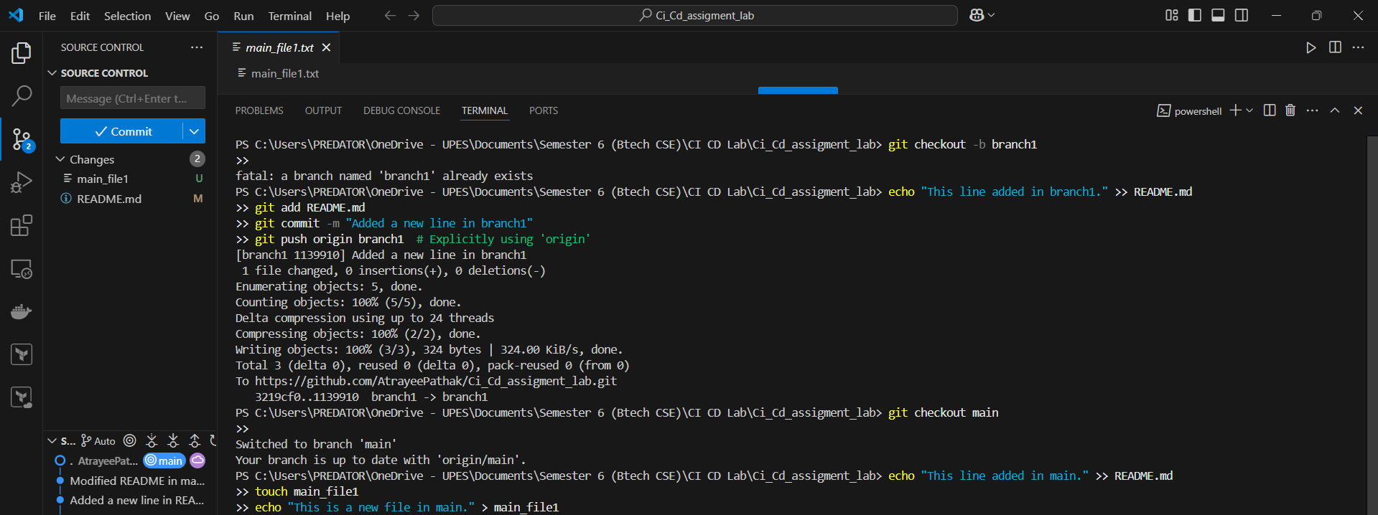

PS C:\Users\PREDATOR\OneDrive - UPES\Documents\Semester 6 (Btech CSE)\CI CD Lab\Ci_Cd_assigment_lab> git checkout -b branch1

>>

fatal: a branch named 'branch1' already exists

PS C:\Users\PREDATOR\OneDrive - UPES\Documents\Semester 6 (Btech CSE)\CI CD Lab\Ci_Cd_assigment_lab> echo "This line added in branch1." >> README.md

>> git add README.md

>> git commit -m "Added a new line in branch1"

>> git push origin branch1 # Explicitly using 'origin'

[branch1 1139910] Added a new line in branch1

1 file changed, 0 insertions(+), 0 deletions(-)

Enumerating objects: 5, done.

Counting objects: 100% (5/5), done.

Delta compression using up to 24 threads

Compressing objects: 100% (2/2), done.

Writing objects: 100% (3/3), 324 bytes | 324.00 KiB/s, done.

Total 3 (delta 0), reused 0 (delta 0), pack-reused 0 (from 0)

To https://github.com/AtrayeePathak/Ci_Cd_assigment_lab.git

3219cf0..1139910 branch1 -> branch1

PS C:\Users\PREDATOR\OneDrive - UPES\Documents\Semester 6 (Btech CSE)\CI CD Lab\Ci_Cd_assigment_lab> git checkout main

>>

Switched to branch 'main'

Your branch is up to date with 'origin/main'.

PS C:\Users\PREDATOR\OneDrive - UPES\Documents\Semester 6 (Btech CSE)\CI CD Lab\Ci_Cd_assigment_lab> echo "This line added in main." >> README.md

>> touch main_file1

>> echo "This is a new file in main." > main_file1

**Task 6**

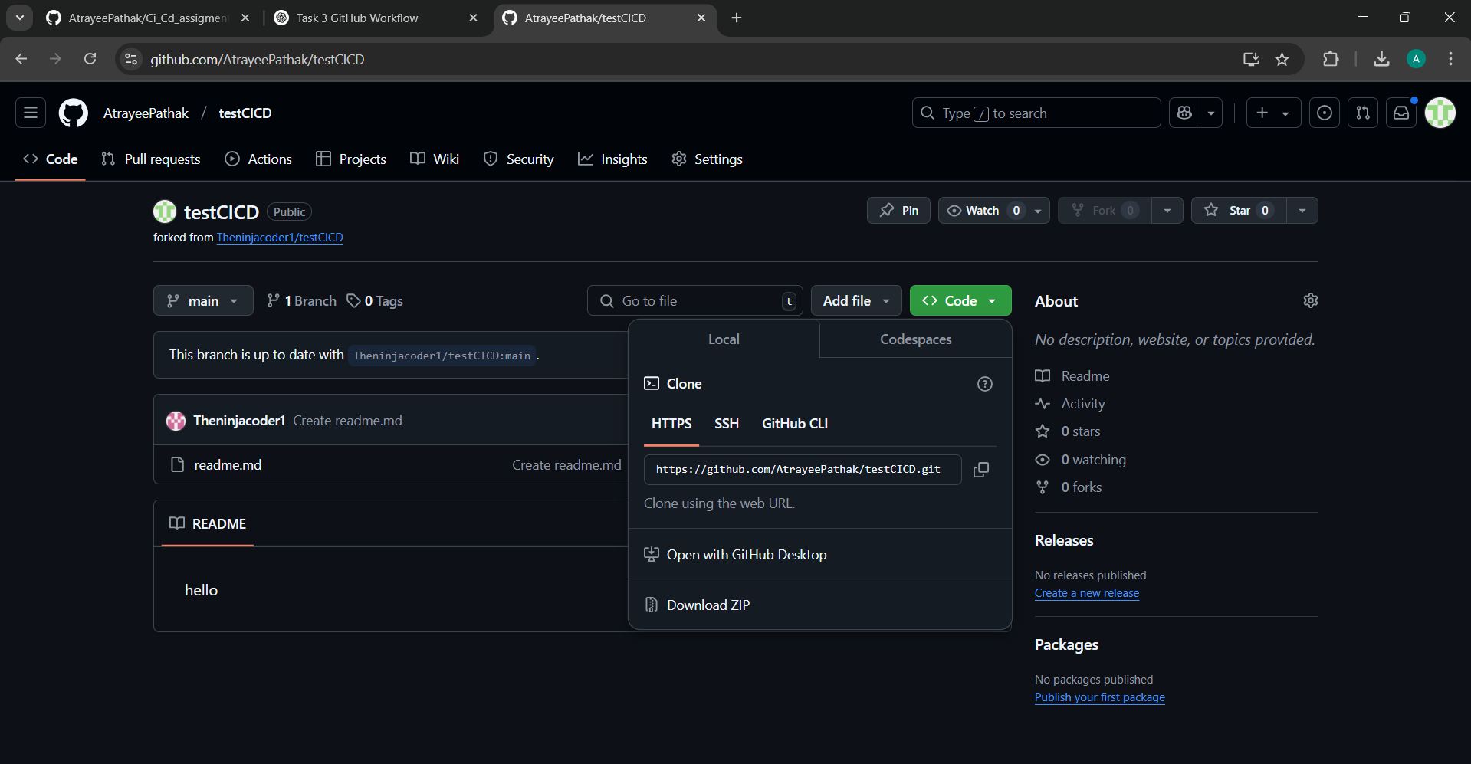

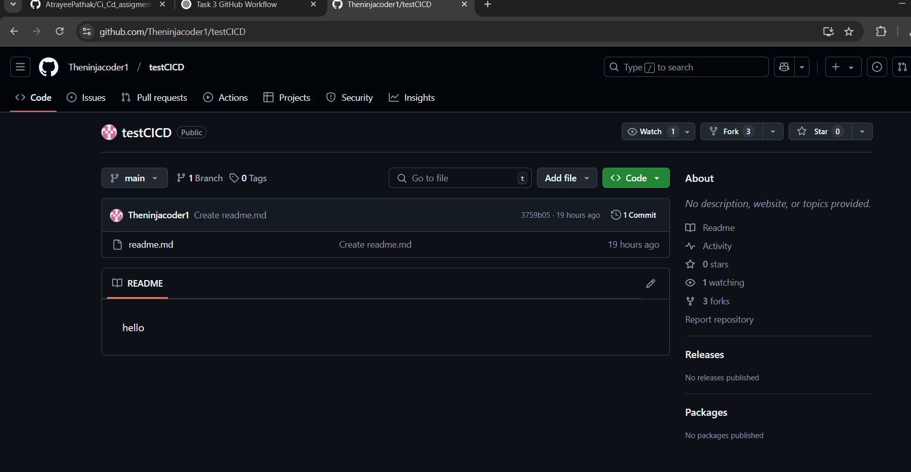

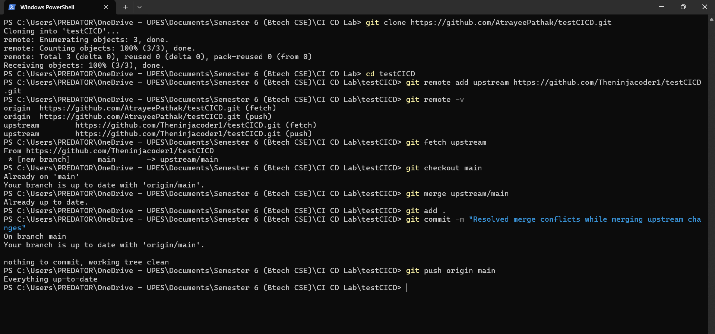

PS C:\Users\PREDATOR\OneDrive - UPES\Documents\Semester 6 (Btech CSE)\CI CD Lab> git clone https://github.com/AtrayeePathak/testCICD.git

Cloning into 'testCICD'...

remote: Enumerating objects: 3, done.

remote: Counting objects: 100% (3/3), done.

remote: Total 3 (delta 0), reused 0 (delta 0), pack-reused 0 (from 0)

Receiving objects: 100% (3/3), done.

PS C:\Users\PREDATOR\OneDrive - UPES\Documents\Semester 6 (Btech CSE)\CI CD Lab> cd testCICD

PS C:\Users\PREDATOR\OneDrive - UPES\Documents\Semester 6 (Btech CSE)\CI CD Lab\testCICD> git remote add upstream https://github.com/Theninjacoder1/testCICD.git

PS C:\Users\PREDATOR\OneDrive - UPES\Documents\Semester 6 (Btech CSE)\CI CD Lab\testCICD> git remote -v

origin https://github.com/AtrayeePathak/testCICD.git (fetch)

origin https://github.com/AtrayeePathak/testCICD.git (push)

upstream https://github.com/Theninjacoder1/testCICD.git (fetch)

upstream https://github.com/Theninjacoder1/testCICD.git (push)

PS C:\Users\PREDATOR\OneDrive - UPES\Documents\Semester 6 (Btech CSE)\CI CD Lab\testCICD> git fetch upstream

From https://github.com/Theninjacoder1/testCICD

* [new branch] main -> upstream/main

PS C:\Users\PREDATOR\OneDrive - UPES\Documents\Semester 6 (Btech CSE)\CI CD Lab\testCICD> git checkout main

Already on 'main'

Your branch is up to date with 'origin/main'.

PS C:\Users\PREDATOR\OneDrive - UPES\Documents\Semester 6 (Btech CSE)\CI CD Lab\testCICD> git merge upstream/main

Already up to date.

PS C:\Users\PREDATOR\OneDrive - UPES\Documents\Semester 6 (Btech CSE)\CI CD Lab\testCICD> git add .

PS C:\Users\PREDATOR\OneDrive - UPES\Documents\Semester 6 (Btech CSE)\CI CD Lab\testCICD> git commit -m "Resolved merge conflicts while merging upstream changes"

On branch main

Your branch is up to date with 'origin/main'.

nothing to commit, working tree clean

PS C:\Users\PREDATOR\OneDrive - UPES\Documents\Semester 6 (Btech CSE)\CI CD Lab\testCICD> git push origin main

Everything up-to-date

PS C:\Users\PREDATOR\OneDrive - UPES\Documents\Semester 6 (Btech CSE)\CI CD Lab\testCICD>